Student’s Name:
Professor’s Name:
Institution;
Projectile motion Lab report
Objectives
- To learn how to analyze the projectile motion of an object when only gravity is influencing the motion
- To learn how to use the interactive simulation tool.
Materials and Methods
Materials: Phet interactive simulation tool, with cannon and cannon ball.
Procedure
- A height of 10m was chosen for the cannon with an initial angle ϴ at zero.
- The velocity was continually adjusted for the shell to hit the red button.
- This was done for all the targets listed on the table below.
- Kinematic equations were used to compute the value of v_{f}
Intial angle | Height | Target position | Accepted Vi | Computed Vi | % error
0 | 10 m | 10 m | 7 m/s | 7 m/s | 0
0 | 10 m | 15.7 m | 11m/s | 11 m/s | 0
0 | 10 m | 19.8 m | 14 m/s | 14 m/s | 0
0 | 10 m | 24.2 m | 17m/s | 17 m/s | 0
0 | 10 m | 30 m | 21 m/s | 21 m/s | 0
Procedure 2
- A height of 12m was chosen and the initial velocity of the shell set at 15m/s.
- The angle of the cannon was adjusted as shown in the table below.
- The distance of the shell was recorded respective to the angle of the cannon.
Initial angle | Height of cannon | Accepted x | Computed x | % error
-20 | 12 m | 16 m | 15.92 m | 0.5%
+40 | 12 m | 32.6 m | 32.52 m | 0.2%
+60 | 12 m | 25.3 m | 25.28m | 0.06%

Calculations
1 0 m
V_{o}=Vxcos$ϴ$ 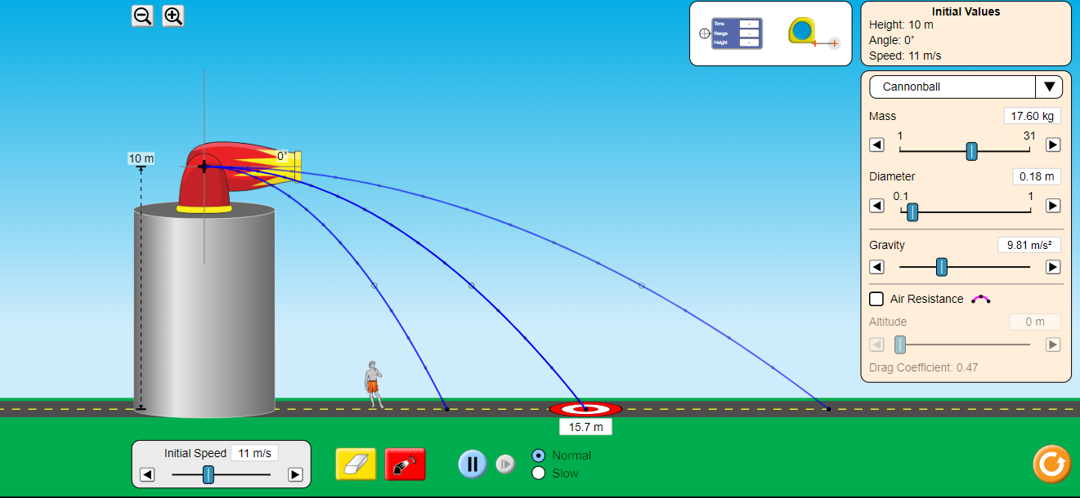
X = V_{o} *t
Vx= initial velocity
X= distance
7cos 0= 7m/s
% error= 0%
30 m
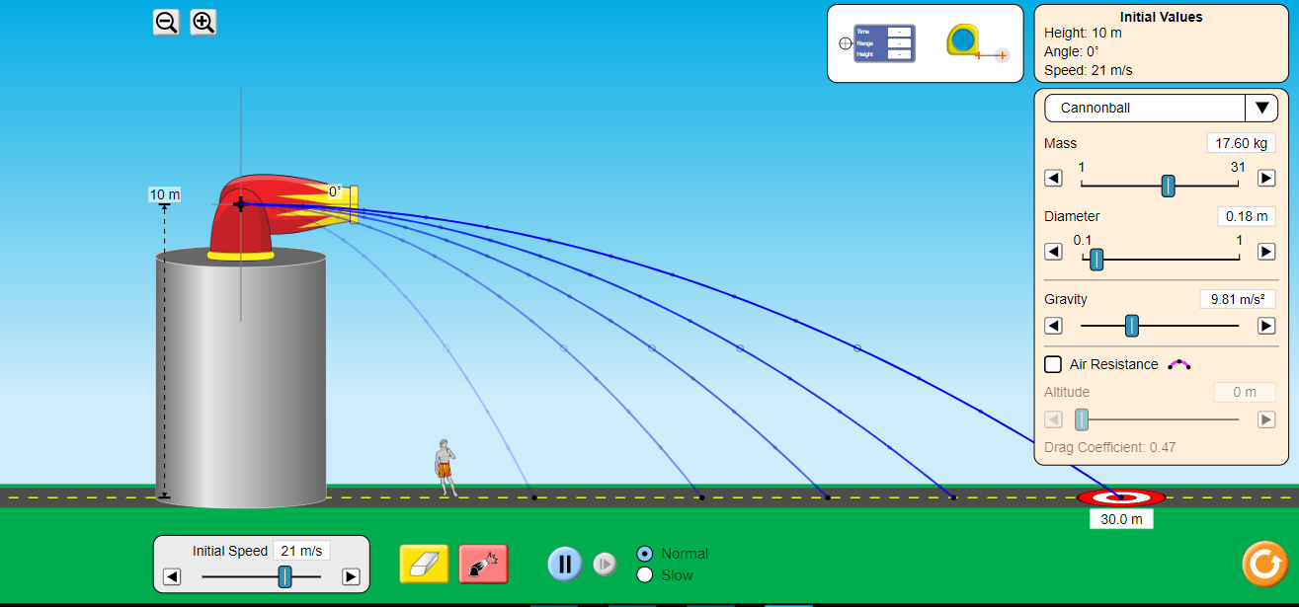
21 cos 0= 21m/s
% error= 0%
Using the equation
V_{o}= Vx cos$ϴ$
X = V_{o} *t
-20 degrees
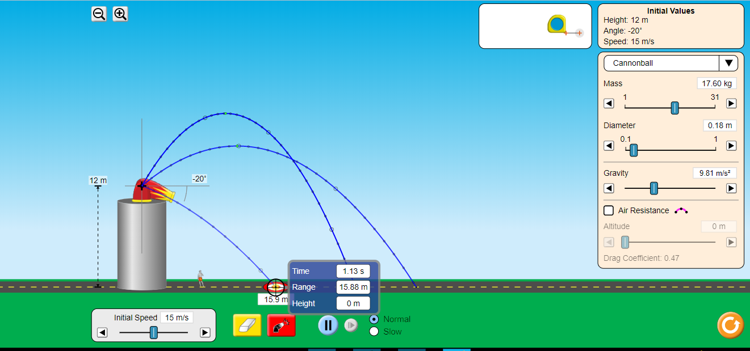
15*cos (-20)= 14.095
14.095*1.113= 15.92 m
% error = 15.92-16/16*100= 0.5%
+40 above horizontal
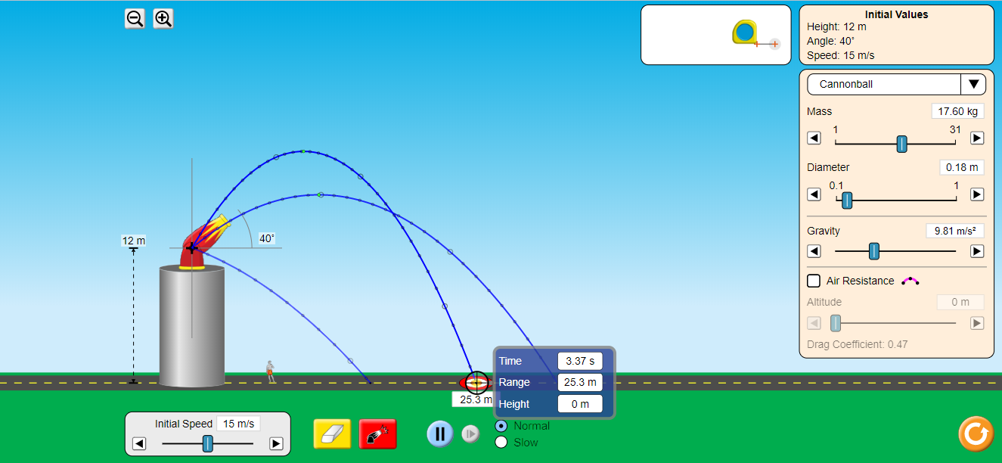
15 cos 40= 11.49 m/s
11.49*2.83 = 32.52m
% error = 32.52-32.6/32.6*100= 0.2%

+ 60 degrees above horizontal
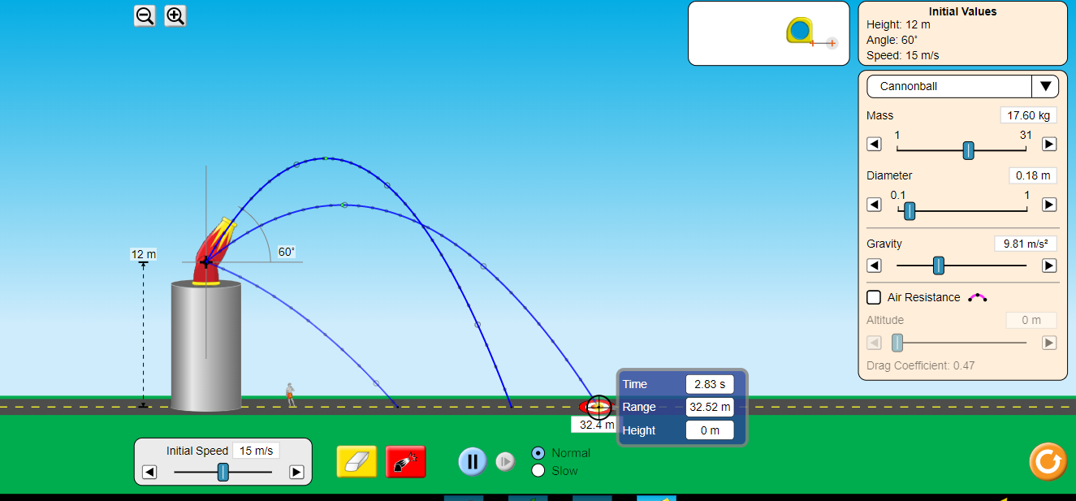
15 cos 60 =7.5m/s
7.5*3.37= 25.28m
%error= 25.28 -25.3/25.3*100= 0.06%
Conclusion
The projectile experiment was a success and distance X was computed. Systematic errors occurred during the experiment but the values obtained were closer to the accurate value. The errors made were very small and the results were near perfect.

